D-311 Unit 0: Introduction

Summary:
Summary: This unit will focus on the overall outline of the course with introductions from instructors and students.

Objectives:
- Introduce instructors, course coordinator and students.
- Discuss administrative and logistics concerns.
- Present the course objectives.
- Explain the course design.
- Explain the course evaluation system.
- Review pre-course work and discuss course expectations.

Unit at a Glance:
Topics | Method | Duration
Introductions, Logistics, Overview | Presentation | 30 Minutes
Unit 1: Decision Making and Situational Awareness | Presentation  and Exercise | 60 Minutes
Unit 2: Introduction to LE&I | Presentation  and Exercise | 30 Minutes
Unit 3: Radios | Presentation  and Exercise | 120 Minutes
Unit 4: Intelligence | Presentation  and Exercise | 90 Minutes
Unit 5: IA Dispatch Environment, General Processes, and WildCAD-E Introduction | Presentation  and Exercise | 240 Minutes
Unit 6: Incident Business Support | Presentation  and Exercise | 60 Minutes
Unit 7: Maps | Presentation  and Exercise | 120 Minutes
Unit 8: Basic Initial Attack Aircraft | Presentation  and Exercise | 120 Minutes
Unit 9: Daily Duties | Presentation  and Exercise | 120 Minutes
Unit 10: Health and Safety | Presentation  and Exercise | 120 Minutes
Cadre Simulation | Presentation | 60 Minutes
Student Simulation #1 | Exam | 180 Minutes
Student Simulation #2 | Exam | 180 Minutes
Total Unit Duration |  | Total 25.5 Hours

Preparation:
This section appears at the beginning of the course and unit. It indicates all steps you need to take to prepare for delivery.

Course Materials:
For each participant:
- WildCAD-E Practice Account and access to practice database
- Laptop with the ability to connect to wifi or internet and access FAMAuth
- Notepad
- Access to Wildland Fire Portal. Each student should have access to all PowerPoint slides and course evaluations that will be built by the cadre before the course.

Classroom:
- Wifi/Internet adequate to support WildCAD-E platform.
- Ability to display images and video on large screen.
- White board or easel access for group breakout.
- Tables to set 4 students and one coach (max).
- Table for instructors

Slide 1
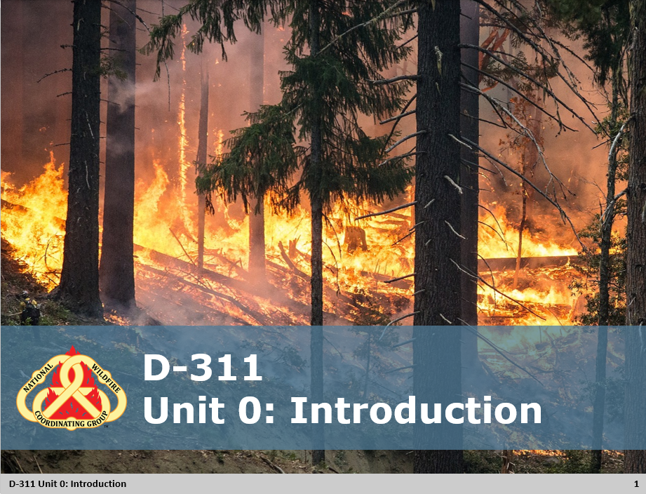
Unit 0: Introduction
Unit Overview
Greet and Orient Students
- Welcome students as they arrive
Welcome to D-311 Course
- Course agenda
  - Time frames
  - Teaching process
  - Simulation
- Housekeeping
  - Transportation
  - Housing
  - Meal schedule/lunches
  - Course hours
- Student course evaluations
  - Students are to complete a unit evaluation at the end of each day. An overall course evaluation will be completed on the final day of class.
  - Lead Instructor: Evaluations will be available in the Wildland Learning Portal for students to complete at the end of each day.

Student Performance
- Unit objectives define what is expected upon completion of that unit.
  - Unit objectives will be presented at the beginning of each unit.
  - These objectives will be measured by exercises throughout each unit.
- There will be three simulations
  - Simulation one is a demonstration by the instructors to show how the process works.
  - Two simulations that will be evaluated by the cadre.
  - At the end of each simulations an AAR will be conducted.
- Students will be evaluated on how well they demonstrate dispatch techniques such as:
  - Utilizing current technology and programs
  - Situational awareness/decision making.
  - Organizing information to be useful
  - Map reading and plotting incidents.
  - Documentation
  - Multi-tasking
  - Communication / interaction skills
  - Accomplishing task given timeframes
- To satisfy the above objectives, the student is required to participate in the entire course and complete all exercises and assignments.

Slide 2
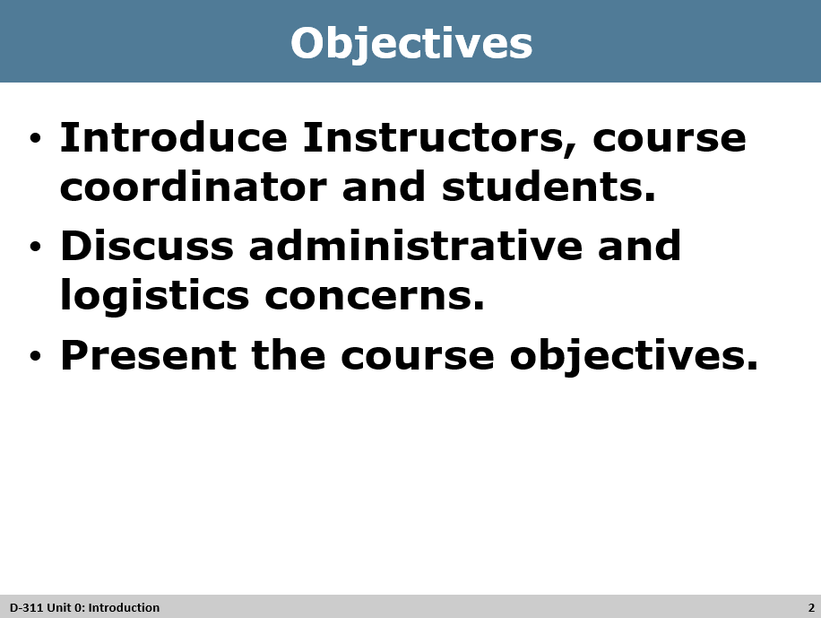
Review Unit Objectives
- Refer the participants to the objectives as listed in the PowerPoint slide. Allow time for the participants to review.
- Present course goal and objectives
  - At the completion of the course, the student will have the necessary information to:
    - Dispatch multiple resources to an incident using standard procedures.
    - Identify the common roles of an IADP in the initial attack dispatch environment.
    - Practice multi-tasking and prioritizing actions in a realistic situation.

Slide 3
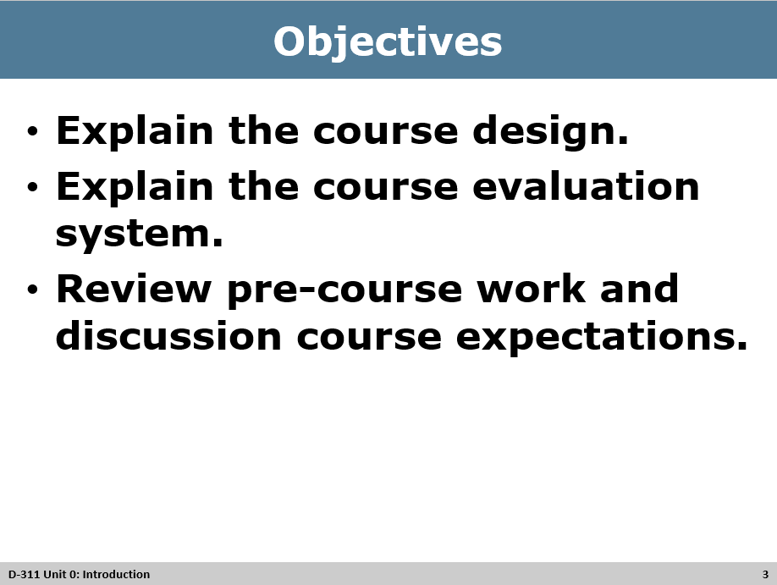
Review Unit Objectives
- Refer the participants to the objectives as listed in the PowerPoint slide. Allow time for the participants to review.
- Present course goal and objectives
  - At the completion of the course, the student will have the necessary information to:
    - Dispatch multiple resources to an incident using standard procedures.
    - Identify the common roles of an IADP in the initial attack dispatch environment.
    - Practice multi-tasking and prioritizing actions in a realistic situation.

Slide 4
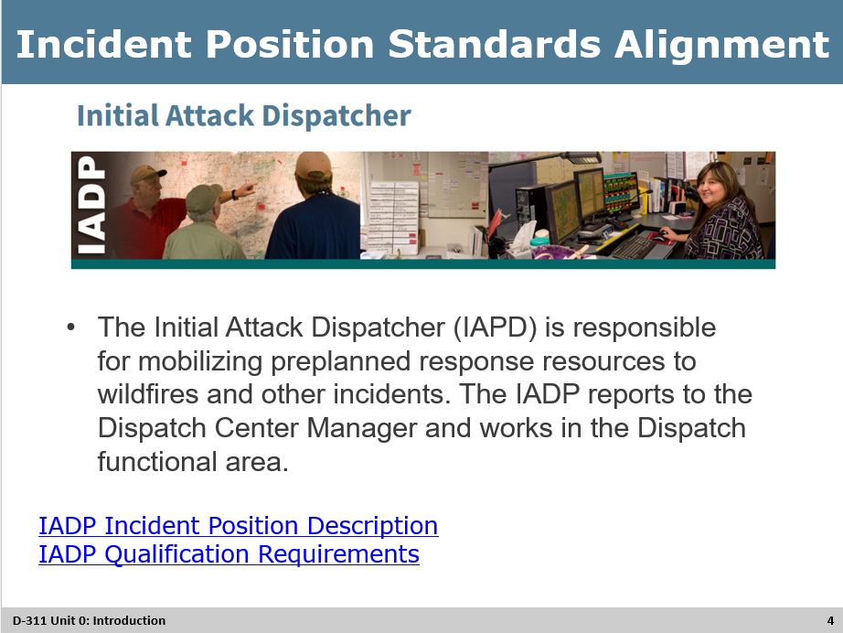
Review Incident Position Standards Alignment
Course design background
- Once a person has successfully completed D-311 and the PTB, it will provide a standard base level of initial attack knowledge and skills. Knowledge and skills such as initial attack environment, WildCAD, intelligence, maps, radio use, decision making, situational awareness, safety, basic aircraft, support, and basic dispatching.
- To be a fully qualified IADP students need to have satisfactory performance as an Expanded Dispatch Recorder (EDRC) AND completion and certification of NWCG Initial Attack Dispatcher (IADP) Position Task Book, PMS 311-60.
- The target audience for this course is for anyone wanting to expand knowledge and skill base to perform as an Initial Attack Dispatcher.

Slide 5
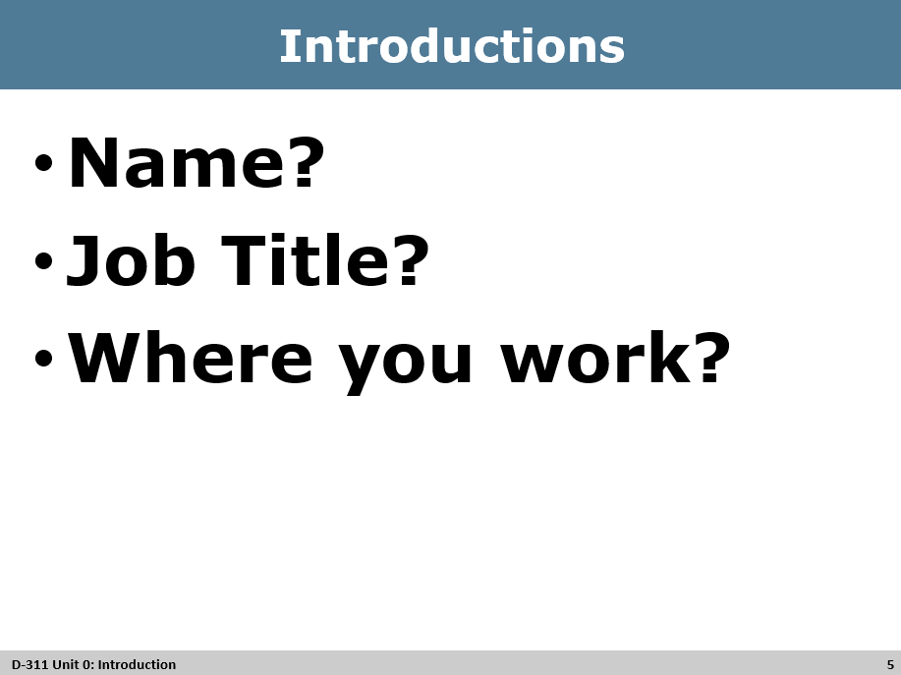
Introductions
Introductions
  - Cadre and Student Introductions
Exercise
Exercise
- Introductions
  - Name, Job Title/Position, Where you work/location?
  - Pick something unique to add. (hobby/highschool mascot/ vacation destination, etc)
- Discuss expectations

Slide 6
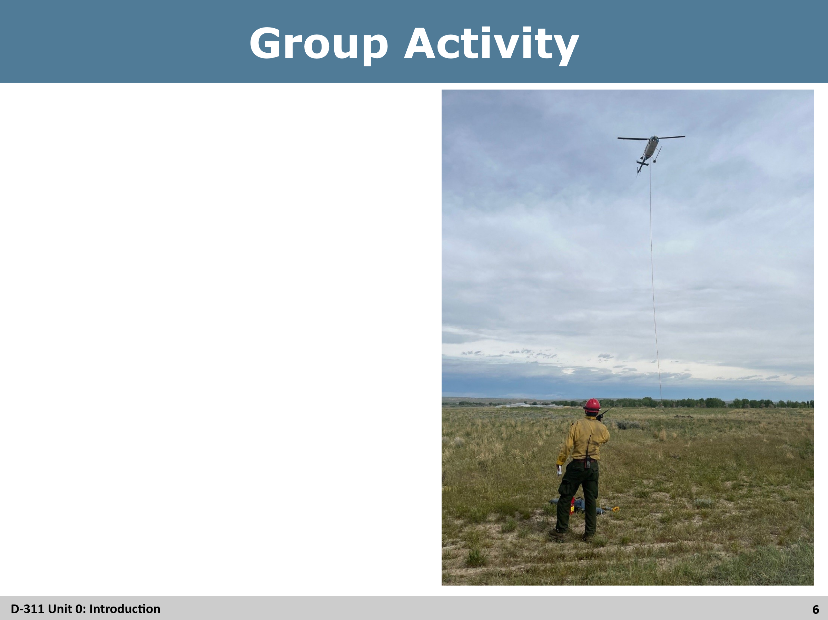
Group Activity
Group Activity
Suggestions could be:
- Building a spaghetti tower
- Paper Airplanes
- Tower Building
- Toilet paper facts
- Ice Breaker Bingo
- Scavenger Hunt
- Family Feud

Slide 7
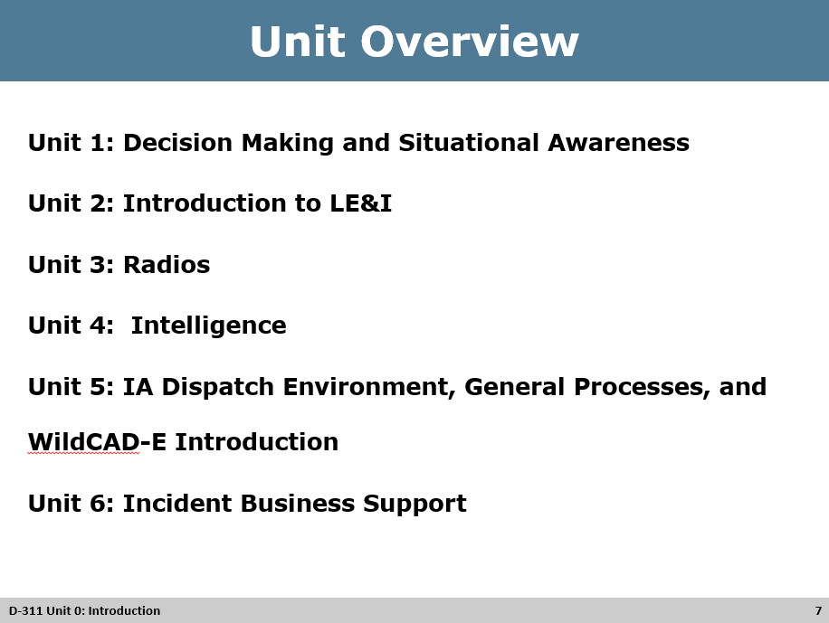
Unit Overview

Slide 8

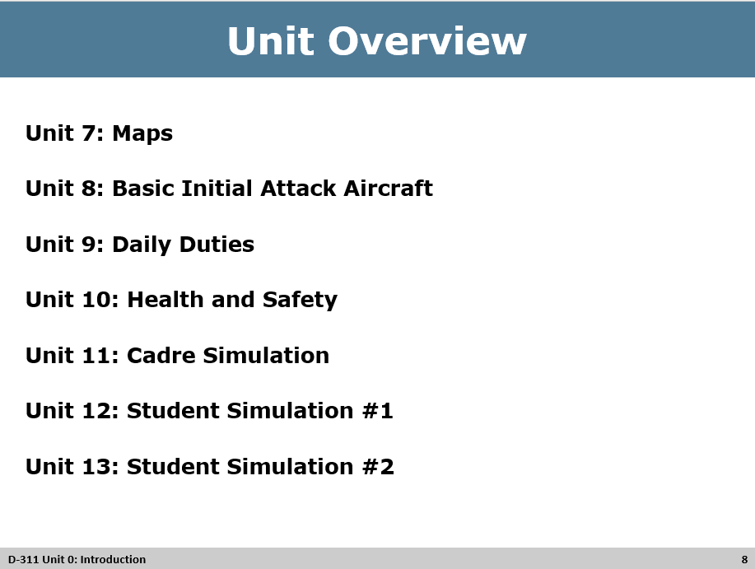

Unit Overview

